SIMATS ENGINEERING

ASSESSMENT TOOL 2-Pseudocode Writing Task

COURSE NAME: R PROGRAMMING COURSE CODE: ITA0404

COURSE OUTCOME COVERED

CO1: Apply R programming fundamentals including data structures, vectors, matrices, arrays,
and class types to perform mathematical operations and manage data effectively. Identify and
implement appropriate control structures to solve a particular programming problem
(Bloom Level -BL3- BL4)
Assessment Tool Weightage: 20%

QUESTIONS: 5 Questions Total Marks: 100

Code of Conduct:

I BoyapatiNandini(192525137) (Name / Reg No) certify that this submission is my original
work and that I have adhered to the guidelines specified for this assessment.
I understand that any violation of academic integrity rules will result in disciplinary action.

Signature of the student:B.Nandini

Instructions to students: Write structured pseudocode (not R syntax) for each scenario. Clearly
show inputs, data structures used, control structures (decision, loop), processing steps, and
outputs. Marks: 10 per question.

Q1. Campus Canteen Billing (Vectors)

1. Algorithm
- Start the program.
- Store the item prices in a numeric vector price.
- Store the quantities ordered in a vector qty.
- Multiply each item's price by its quantity to calculate the item bill.
- Calculate the total bill by adding all item bills.
- If the total bill exceeds ₹500, apply a 10% discount; otherwise, the discount is zero.
- Calculate the final payable amount.
- Display the item bills, total bill, discount, and final payable amount.
- Stop the program.

2. Pseudocode – Algorithm Design
BEGIN
INPUT price vector and quantity vector
bill = price × quantity
total = SUM(bill)
IF total > 500 THEN
discount = total × 0.10
ELSE
discount = 0
END IF

payable = total − discount

DISPLAY bill
DISPLAY total, discount, payable
END

3. R Program Code
price <- c(100, 150, 200, 80)
qty <- c(2, 1, 1, 2)

bill <- price * qty
total <- sum(bill)

if (total > 500) {
discount <- total * 0.10
} else {
discount <- 0
}

payable <- total - discount

cat("Item Bills:", bill, "\n")
cat("Total Bill: Rs.", total, "\n")
cat("Discount: Rs.", discount, "\n")
cat("Final Payable Amount: Rs.", payable, "\n")
4.Output :

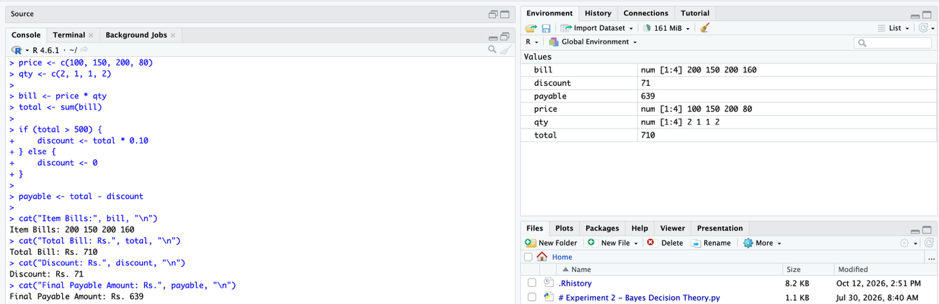

Q2. Student Marks Analyser

1. Algorithm
- Start the program.
- Store the marks of 40 students in a vector.
- Calculate the class average using the sum of marks divided by 40.
- Find the highest and lowest marks.
- Count the students who scored below 40.
- Calculate the number and percentage of students who passed.
- If more than 80% passed, display “Class Performance: Good”; otherwise, display “Needs Improvement”.
- Display all results.
- Stop the program.

2. Pseudocode – Algorithm Design
BEGIN
INPUT marks of 40 students
average = SUM(marks) / 40
highest = MAX(marks)
lowest = MIN(marks)
fail_count = COUNT(marks < 40)
pass_count = 40 - fail_count
pass_percentage = (pass_count / 40) × 100
DISPLAY average, highest, lowest, fail_count

IF pass_percentage > 80 THEN
DISPLAY "Class Performance: Good"
ELSE
DISPLAY "Class Performance: Needs Improvement"
END IF
END
3. R Program Code
marks <- c(78, 85, 90, 65, 72, 88, 91, 56, 45, 76,
82, 69, 95, 40, 73, 87, 92, 61, 79, 84,
68, 74, 89, 93, 55, 80, 77, 86, 94, 62,
71, 83, 96, 58, 67, 75, 81, 90, 43, 88)

average <- mean(marks)
highest <- max(marks)
lowest <- min(marks)
fail_count <- sum(marks < 40)
pass_count <- sum(marks >= 40)
pass_percentage <- (pass_count / length(marks)) * 100

cat("Class Average:", round(average, 2), "\n")
cat("Highest Mark:", highest, "\n")
cat("Lowest Mark:", lowest, "\n")
cat("Number of Failures:", fail_count, "\n")
cat("Pass Percentage:", pass_percentage, "%\n")

if (pass_percentage > 80) {
cat("Class Performance: Good\n")
} else {
cat("Class Performance: Needs Improvement\n")
}
4. Output
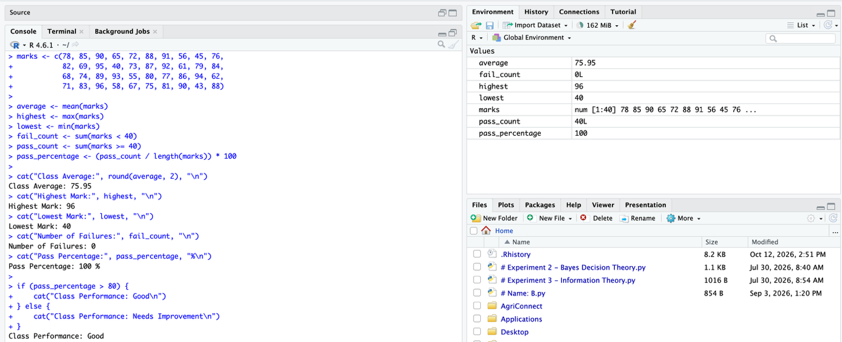

Q3. Hostel Room Allocation Matrix

1. Algorithm
- Start the program.
- Create a 4 × 5 matrix representing four floors and five rooms per floor.
- Store 1 for occupied rooms and 0 for vacant rooms.
- Initialize the total number of vacant rooms to zero.
- For each floor, count the rooms containing zero.
- Add each floor's vacancies to the total.
- Find the maximum number of vacancies and identify the corresponding floor.
- Display vacancies on each floor, total vacancies, and the floor with maximum vacancies.
- Stop the program.

2. Pseudocode – Algorithm Design
BEGIN
CREATE 4 × 5 matrix ROOM
total_vacant = 0
FOR each floor i from 1 to 4
vacant[i] = COUNT(ROOM[i, ] = 0)
total_vacant = total_vacant + vacant[i]
END FOR

max_vacant = MAX(vacant)
floor_number = POSITION(max_vacant in vacant)

DISPLAY vacant rooms on each floor
DISPLAY total_vacant
DISPLAY floor_number
END
3. R Program Code
room <- matrix(c(
1, 0, 1, 0, 1,
0, 0, 1, 1, 0,
1, 1, 0, 0, 0,
0, 1, 0, 0, 1
), nrow = 4, byrow = TRUE)

vacant <- rowSums(room == 0)
total_vacant <- sum(vacant)
max_vacant <- max(vacant)
floor_number <- which(vacant == max_vacant)

cat("Vacant Rooms on Each Floor:", vacant, "\n")
cat("Total Vacant Rooms:", total_vacant, "\n")
cat("Floor(s) with Maximum Vacancies:", floor_number, "\n")
4.output :
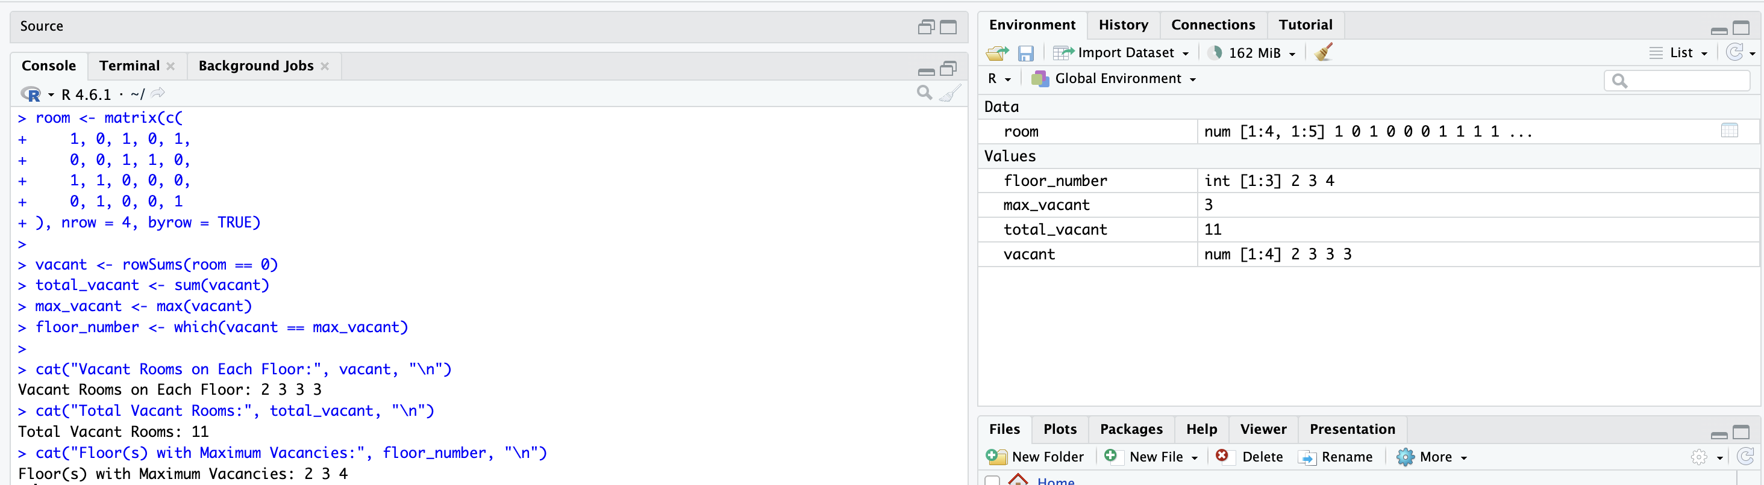

Q4. Monthly Electricity Bill Calculator

1. Algorithm
- Start the program.
- Read the electricity units consumed.
- If consumption is at most 100 units, charge ₹3 per unit.
- If consumption is between 101 and 200 units, charge ₹3 for the first 100 units and ₹5 for the remaining units.
- If consumption exceeds 200 units, charge ₹3 for the first 100 units, ₹5 for the next 100 units, and ₹8 for the remaining units.
- Add the fixed charge of ₹50.
- Display the units, energy charge, fixed charge, and total bill.
- Stop the program.

2. Pseudocode – Algorithm Design
BEGIN
INPUT units
IF units <= 100 THEN
energy_charge = units × 3
ELSE IF units <= 200 THEN
energy_charge = 100 × 3 + (units - 100) × 5
ELSE
energy_charge = 100 × 3 + 100 × 5
+ (units - 200) × 8
END IF

fixed_charge = 50
total_bill = energy_charge + fixed_charge

DISPLAY energy_charge
DISPLAY fixed_charge
DISPLAY total_bill
END

3. R Program Code
units <- 250

if (units <= 100) {
energy_charge <- units * 3
} else if (units <= 200) {
energy_charge <- 100 * 3 + (units - 100) * 5
} else {
energy_charge <- 100 * 3 + 100 * 5 +
(units - 200) * 8
}

fixed_charge <- 50
total_bill <- energy_charge + fixed_charge

cat("Units Consumed:", units, "\n")
cat("Energy Charge: Rs.", energy_charge, "\n")
cat("Fixed Charge: Rs.", fixed_charge, "\n")
cat("Total Electricity Bill: Rs.", total_bill, "\n")
4.output :
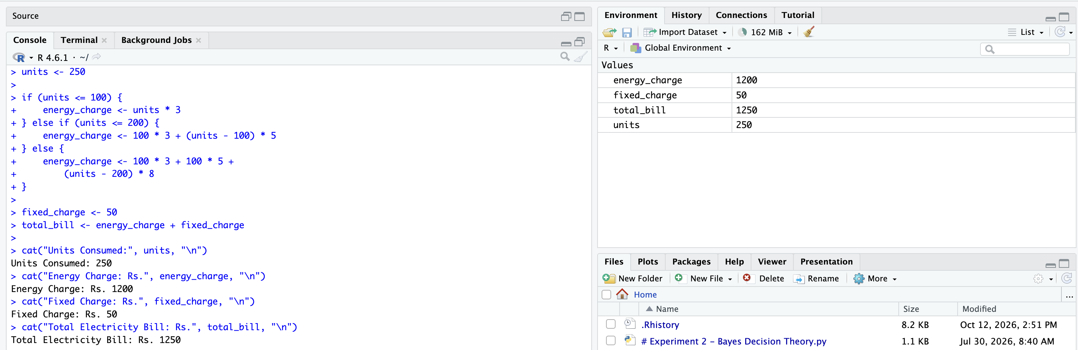

Q5. Sales Report Using Matrix Operations

1. Algorithm
- Start the program.
- Create a 3 × 4 sales matrix for three products over four weeks.
- Calculate the total sales for each product by adding its row values.
- Calculate the weekly total by adding each column.
- Identify the product with the highest total sales.
- Identify the week with the highest total sales.
- Transpose the matrix so that weeks become rows and products become columns.
- Display the product totals, weekly totals, best-performing product, best week, and transposed matrix.
- Stop the program.

2. Pseudocode – Algorithm Design
BEGIN
CREATE 3 × 4 matrix SALES
product_total = ROW_SUMS(SALES)
weekly_total = COLUMN_SUMS(SALES)

best_product = POSITION(MAX(product_total))
best_week = POSITION(MAX(weekly_total))

transposed_sales = TRANSPOSE(SALES)

DISPLAY product_total
DISPLAY weekly_total
DISPLAY best_product and best_week
DISPLAY transposed_sales
END

3. R Program Code
sales <- matrix(c(
100, 120, 150, 130,
200, 180, 220, 250,
150, 170, 160, 190
), nrow = 3, byrow = TRUE)

rownames(sales) <- c("Product A", "Product B", "Product C")
colnames(sales) <- c("Week 1", "Week 2", "Week 3", "Week 4")

product_total <- rowSums(sales)
weekly_total <- colSums(sales)

best_product <- names(which.max(product_total))
best_week <- names(which.max(weekly_total))

transposed_sales <- t(sales)

cat("Total Sales per Product:\n")
print(product_total)

cat("Weekly Total Sales:\n")
print(weekly_total)

cat("Best Performing Product:", best_product, "\n")
cat("Best Week:", best_week, "\n")

cat("Transposed Sales Matrix:\n")
print(transposed_sales)

4. Output
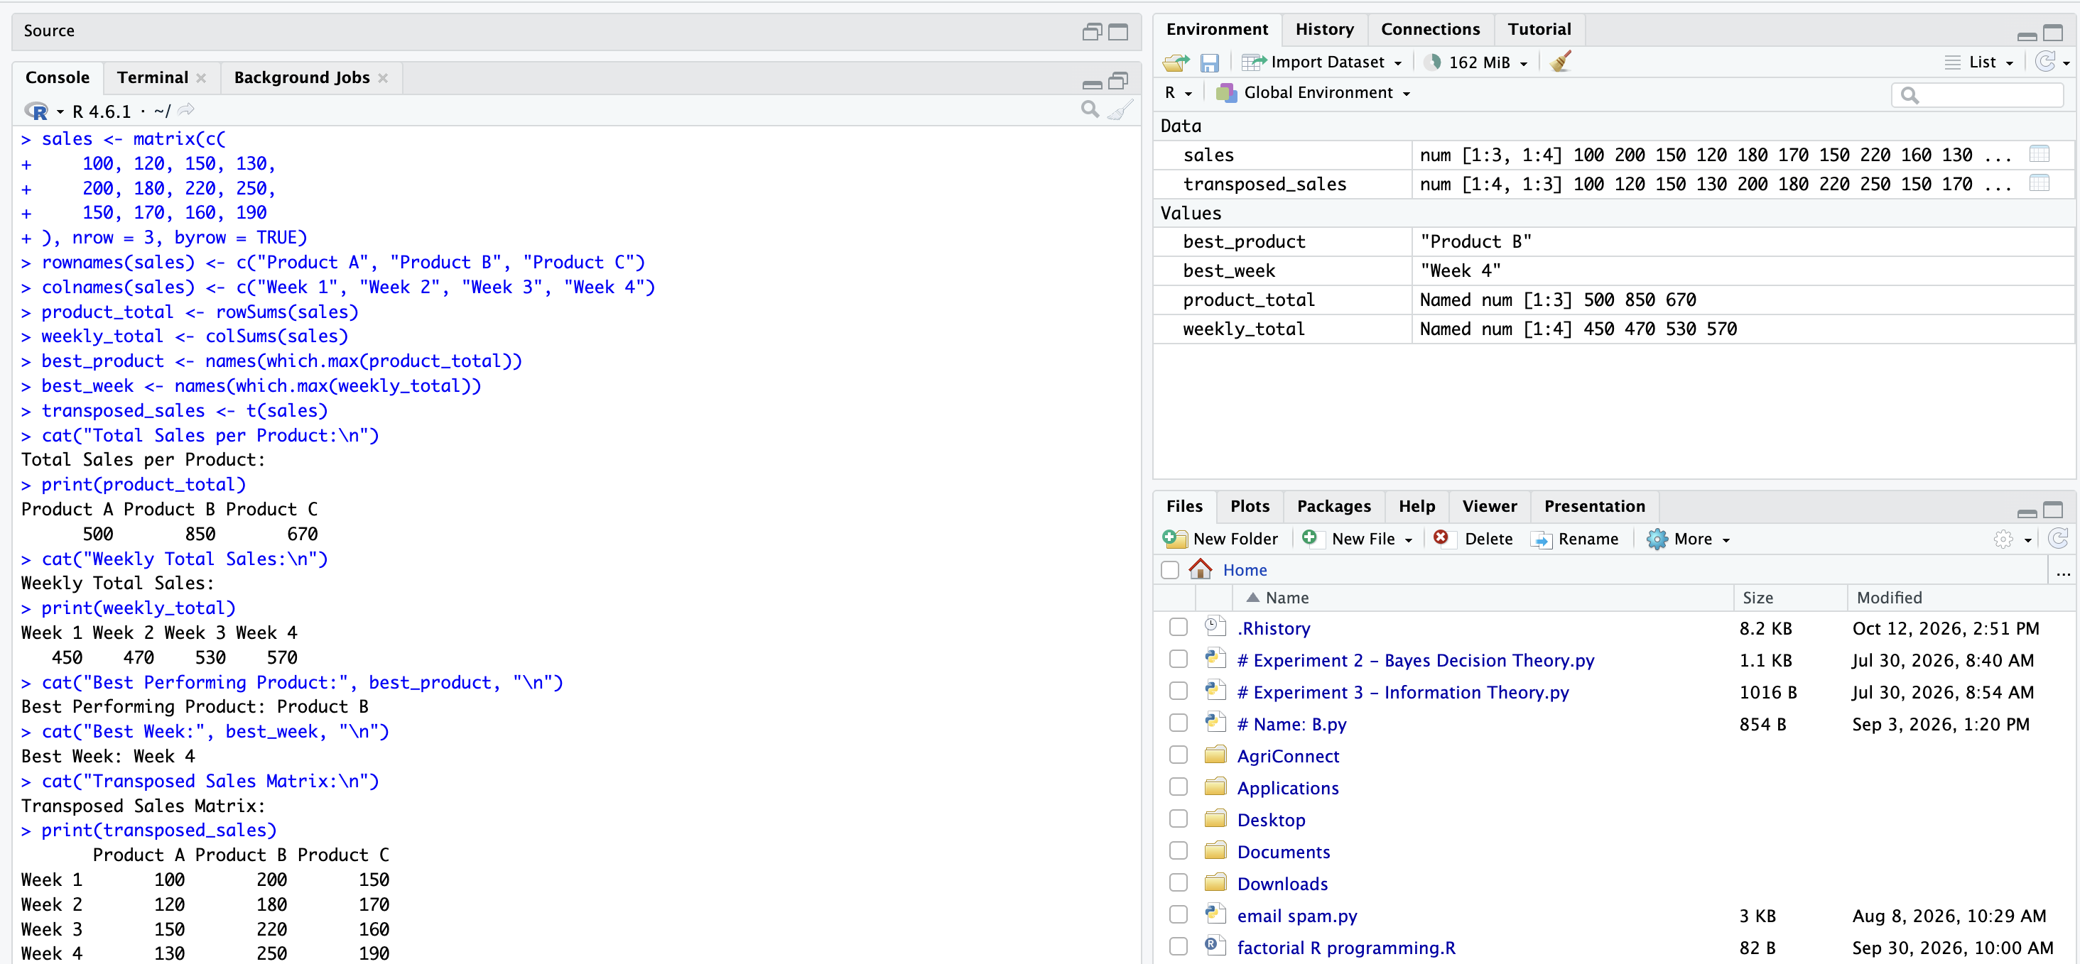

Q6. Library Book Management Using Lists

1. Algorithm
- Start the program.
- Create a list containing five books.
- Store each book's title, author, publication year, and availability status.
- Traverse the list and display books published after 2015.
- Read the title of the book to be borrowed.
- Search the list for the entered title.
- If the book is found and available, update its availability to FALSE.
- If the book is unavailable, display an appropriate message.
- If the title is not found, display “Book title not found”.
- Display the updated book details and stop.

2. Pseudocode – Algorithm Design
BEGIN
CREATE a list BOOKS containing 5 book records
FOR each book B in BOOKS
IF B.YEAR > 2015 THEN
DISPLAY B details
END IF
END FOR

INPUT borrow_title
found = FALSE

FOR each book B in BOOKS
IF B.TITLE = borrow_title THEN
found = TRUE

IF B.AVAILABLE = TRUE THEN
B.AVAILABLE = FALSE
DISPLAY "Book borrowed successfully"
ELSE
DISPLAY "Book is already unavailable"
END IF
END IF
END FOR

IF found = FALSE THEN
DISPLAY "Book title not found"
END IF
END

3. R Program Code
books <- list(
list(title = "Python Basics", author = "Ravi",
year = 2018, available = TRUE),
list(title = "Data Science", author = "Anu",
year = 2020, available = TRUE),
list(title = "C Programming", author = "Kiran",
year = 2012, available = TRUE),
list(title = "Machine Learning", author = "Priya",
year = 2022, available = TRUE),
list(title = "R Programming", author = "Arun",
year = 2016, available = TRUE)
)

cat("Books Published After 2015:\n")

for (i in seq_along(books)) {
if (books[[i]]$year > 2015) {
cat(books[[i]]$title, "-",
books[[i]]$author, "-",
books[[i]]$year, "\n")
}
}

borrow_title <- "Data Science"
found <- FALSE

for (i in seq_along(books)) {
if (tolower(books[[i]]$title) == tolower(borrow_title)) {
found <- TRUE

if (books[[i]]$available == TRUE) {
books[[i]]$available <- FALSE
cat("Book borrowed successfully\n")
} else {
cat("Book is already unavailable\n")
}

break
}
}

if (found == FALSE) {
cat("Book title not found\n")
}

cat("Updated Availability:",
books[[2]]$available, "\n")

4. Output
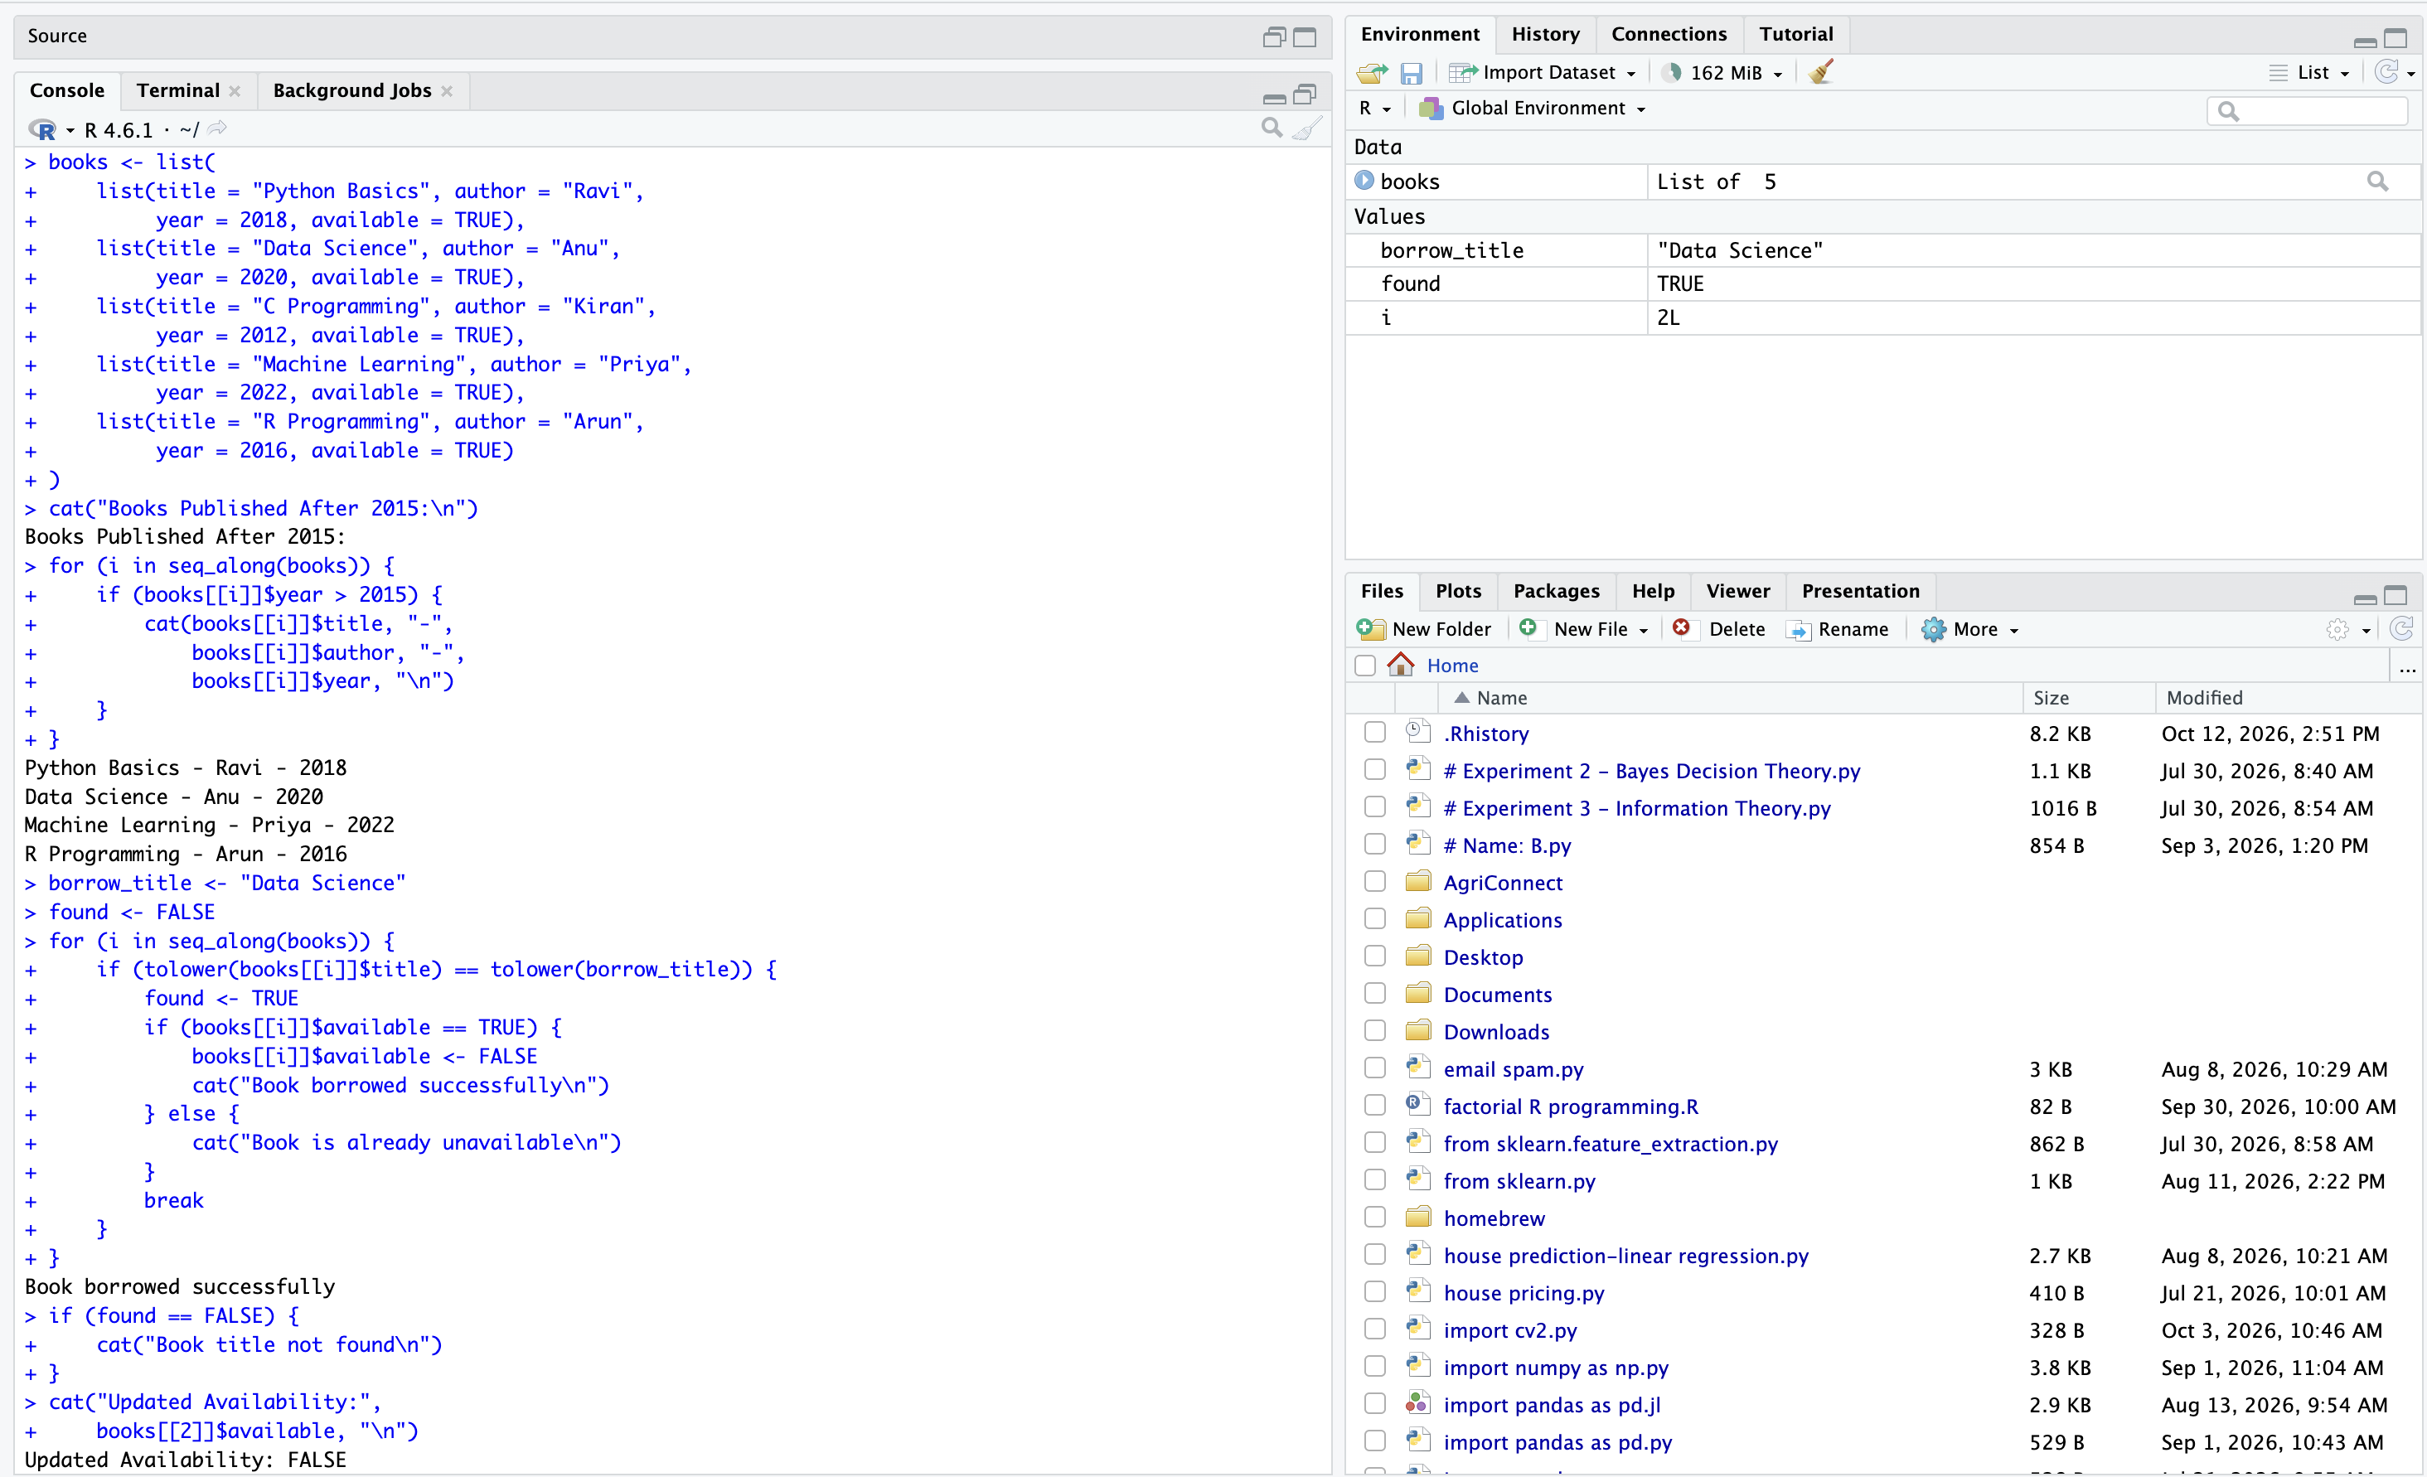

Q7. Temperature Data Cleaning

1. Algorithm
- Start the program.
- Store 30 daily temperature readings in a vector, including missing values.
- Count the missing values.
- Calculate the mean using only valid temperature readings.
- Replace every missing value with the calculated mean.
- Create a new vector to store temperature categories.
- Classify each reading as Cold if below 20°C, Moderate if between 20°C and 30°C inclusive, or Hot if above 30°C.
- Display the missing-value count, cleaned temperatures, and categories.
- Stop the program.

2. Pseudocode – Algorithm Design
BEGIN
INPUT temperature vector TEMP[30]
missing_count = COUNT(TEMP contains NA)
mean_temp = MEAN(TEMP excluding NA)

FOR i from 1 to 30
IF TEMP[i] is NA THEN
TEMP[i] = mean_temp
END IF
END FOR

CREATE empty vector CATEGORY

FOR i from 1 to 30
IF TEMP[i] < 20 THEN
CATEGORY[i] = "Cold"
ELSE IF TEMP[i] <= 30 THEN
CATEGORY[i] = "Moderate"
ELSE
CATEGORY[i] = "Hot"
END IF
END FOR

DISPLAY missing_count
DISPLAY TEMP
DISPLAY CATEGORY
END

3. R Program Code
temp <- c(18, 22, NA, 31, 25, 19, 28, 33, NA, 21,
17, 26, 30, 35, 24, NA, 20, 29, 32, 16,
27, 23, 34, 18, 25, 31, 22, 28, 19, 30)

missing_count <- sum(is.na(temp))
mean_temp <- mean(temp, na.rm = TRUE)

temp[is.na(temp)] <- mean_temp

category <- character(length(temp))

for (i in seq_along(temp)) {
if (temp[i] < 20) {
category[i] <- "Cold"
} else if (temp[i] <= 30) {
category[i] <- "Moderate"
} else {
category[i] <- "Hot"
}
}

cat("Missing Values:", missing_count, "\n")
cat("Mean Temperature:", round(mean_temp, 2), "\n")
cat("Cleaned Temperatures:\n")
print(round(temp, 2))
cat("Temperature Categories:\n")
print(category)

4. Output
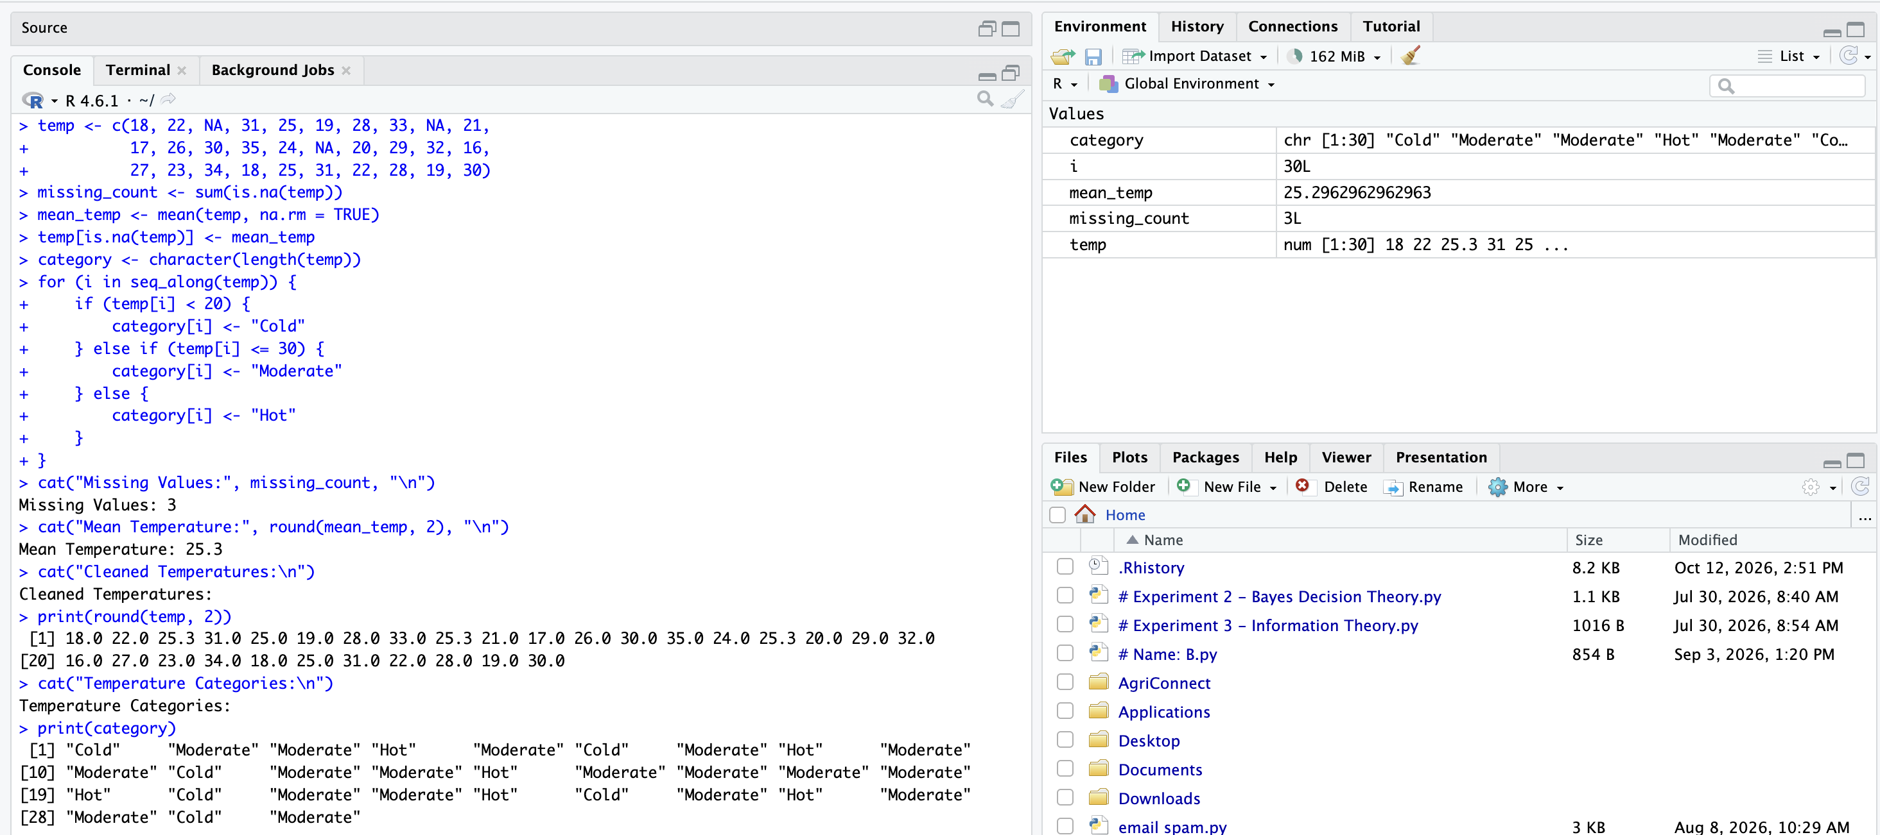

Q8. Exam Seating Using 3D Arrays

1. Algorithm
- Start the program.
- Create a three-dimensional array with 3 blocks, 4 rows, and 5 columns.
- Store student register numbers in occupied seats and 0 in empty seats.
- Initialize the occupancy count of each block to zero.
- Traverse each block, row, and column using nested loops.
- Increment the block's occupancy count whenever a seat contains a non-zero register number.
- Find the block with the highest occupancy.
- Retrieve the register number at Block 2, Row 3, Column 4.
- Display the occupancy of each block, the block with maximum occupancy, and the specified register number.
- Stop the program.

2. Pseudocode – Algorithm Design
BEGIN
CREATE 3D array SEATS[3][4][5]
INITIALIZE OCCUPIED[1..3] = 0
FOR block b from 1 to 3
FOR row r from 1 to 4
FOR column c from 1 to 5
IF SEATS[b][r][c] != 0 THEN
OCCUPIED[b] = OCCUPIED[b] + 1
END IF
END FOR
END FOR
END FOR

highest = MAX(OCCUPIED)
best_block = POSITION(highest in OCCUPIED)
register_no = SEATS[2][3][4]

DISPLAY OCCUPIED
DISPLAY best_block
DISPLAY register_no
END

3. R Program Code
seats <- array(0, dim = c(3, 4, 5))

seats[1, , ] <- matrix(c(
101, 102, 0, 104, 105,
106, 0, 108, 109, 110,
111, 112, 113, 0, 115,
116, 117, 118, 119, 0
), nrow = 4, byrow = TRUE)

seats[2, , ] <- matrix(c(
201, 202, 203, 204, 0,
206, 207, 0, 209, 210,
211, 212, 213, 214, 215,
216, 0, 218, 219, 220
), nrow = 4, byrow = TRUE)

seats[3, , ] <- matrix(c(
301, 0, 303, 304, 0,
306, 307, 308, 0, 310,
311, 312, 0, 314, 315,
0, 317, 318, 319, 320
), nrow = 4, byrow = TRUE)

occupied <- integer(3)

for (b in 1:3) {
for (r in 1:4) {
for (c in 1:5) {
if (seats[b, r, c] != 0) {
occupied[b] <- occupied[b] + 1
}
}
}
}

best_block <- which(occupied == max(occupied))
register_no <- seats[2, 3, 4]

cat("Occupied Seats in Block 1:", occupied[1], "\n")
cat("Occupied Seats in Block 2:", occupied[2], "\n")
cat("Occupied Seats in Block 3:", occupied[3], "\n")
cat("Block(s) with Highest Occupancy:", best_block, "\n")
cat("Register Number at Block 2, Row 3, Column 4:",
register_no, "\n")

4. Output
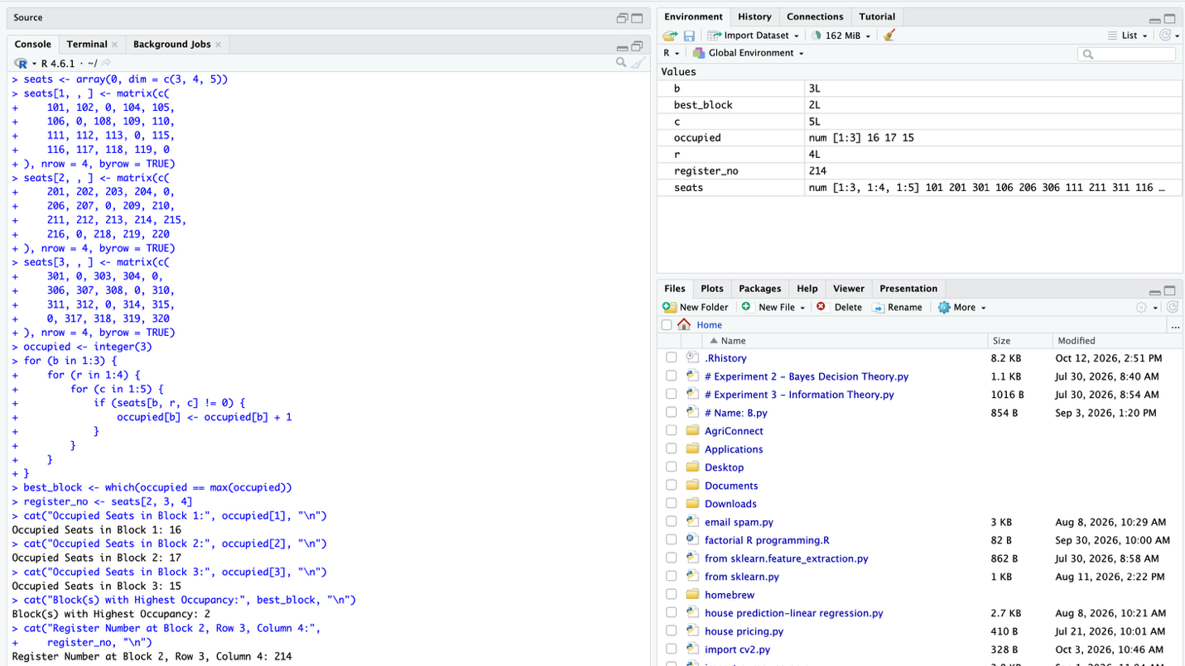

Q9. Employee Data Frame Processing

1. Algorithm
- Start the program.
- Create a data frame containing employee ID, name, department, and salary.
- Select employees whose department is IT and salary is greater than ₹50,000.
- Identify the unique departments in the data frame.
- Calculate the average salary for each department.
- Create a new column named NewSalary.
- Give employees earning below ₹30,000 a 10% raise.
- Keep the salary unchanged for other employees.
- Display the filtered employees, department-wise average salaries, and updated data frame.
- Stop the program.

2. Pseudocode – Algorithm Design
BEGIN
CREATE data frame EMPLOYEE
FILTER employees WHERE
Department = "IT" AND Salary > 50000
DISPLAY filtered employees

FIND unique departments

FOR each department D
CALCULATE average salary for D
DISPLAY D and average salary
END FOR

FOR each employee E
IF E.Salary < 30000 THEN
E.NewSalary = E.Salary × 1.10
ELSE
E.NewSalary = E.Salary
END IF
END FOR

ADD NewSalary column to EMPLOYEE
DISPLAY updated EMPLOYEE
END

3. R Program Code
employee <- data.frame(
EmpID = c(101, 102, 103, 104, 105, 106),
Name = c("Asha", "Ravi", "Priya", "Kiran", "Anu", "Rahul"),
Department = c("IT", "HR", "IT", "Finance", "HR", "IT"),
Salary = c(60000, 28000, 75000, 45000, 25000, 29000)
)

cat("IT Employees Earning Above Rs. 50000:\n")
selected <- subset(employee,
Department == "IT" & Salary > 50000)
print(selected)

cat("\nAverage Salary per Department:\n")
average_salary <- aggregate(
Salary ~ Department,
data = employee,
FUN = mean
)
print(average_salary)

employee$NewSalary <- ifelse(
employee$Salary < 30000,
employee$Salary * 1.10,
employee$Salary
)

cat("\nUpdated Employee Data:\n")
print(employee)

4. Output
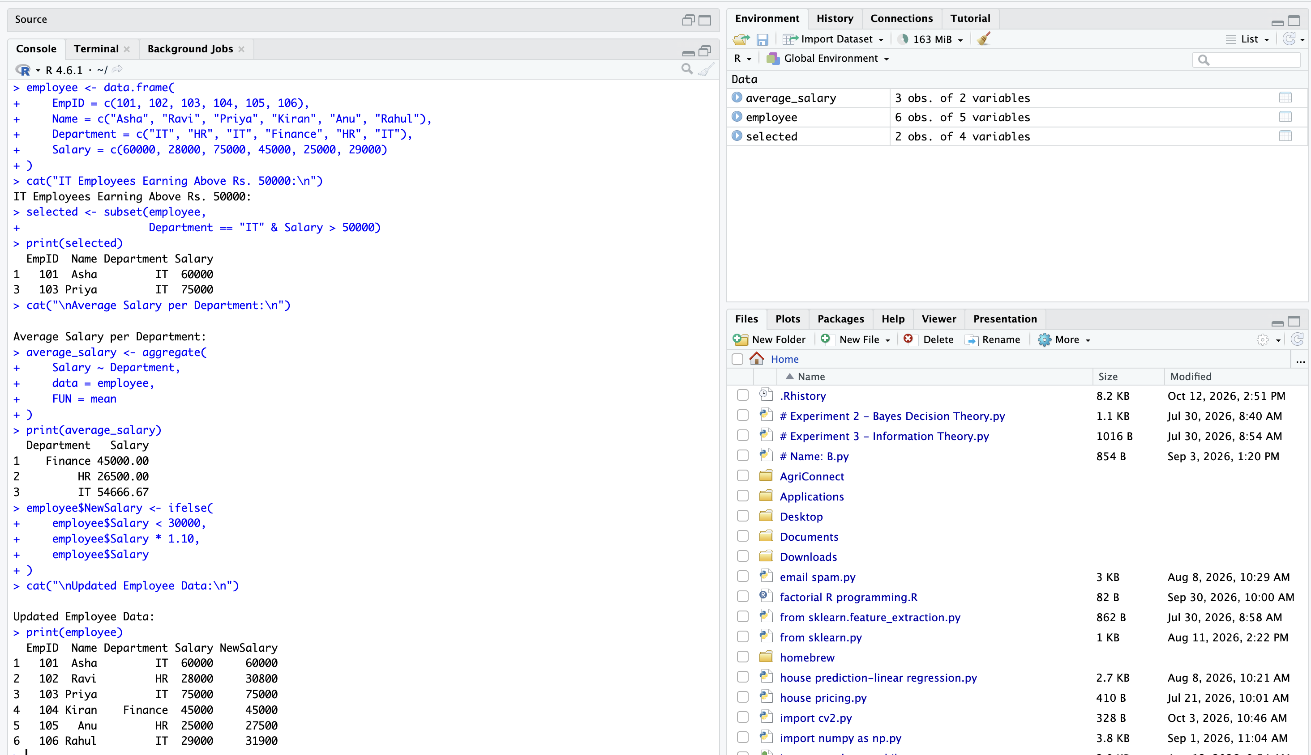

Q10. Prime Number and Series Generator for a Maths Club

1. Algorithm
- Start the program.
- Read an integer N from the user.
- Validate that N is a positive integer. If invalid, request another input.
- Create an empty vector to store prime numbers.
- Check each number from 2 through N for divisibility by integers from 2 to its square root.
- Use a flag to determine whether each number is prime.
- Append every prime number to the prime vector.
- Calculate and display the sum and count of the prime numbers.
- Create an empty Fibonacci vector.
- Generate the first N Fibonacci terms using the previous two terms.
- Display the Fibonacci vector and stop the program.

2. Pseudocode – Algorithm Design
BEGIN
INPUT N
WHILE N is not a positive integer
DISPLAY "Enter a valid positive integer"
INPUT N
END WHILE

CREATE empty vector PRIMES

FOR NUM from 2 to N
FLAG = TRUE

FOR DIVISOR from 2 to floor(square root of NUM)
IF NUM MOD DIVISOR = 0 THEN
FLAG = FALSE
EXIT inner loop
END IF
END FOR

IF FLAG = TRUE THEN
APPEND NUM to PRIMES
END IF
END FOR

prime_sum = SUM(PRIMES)
prime_count = LENGTH(PRIMES)

DISPLAY PRIMES
DISPLAY prime_sum and prime_count

CREATE empty vector FIBONACCI
A = 0
B = 1

REPEAT N times
APPEND A to FIBONACCI
NEXT = A + B
A = B
B = NEXT
END REPEAT

DISPLAY FIBONACCI
END

3. R Program Code
N <- 10

if (N <= 0 || N != floor(N)) {
cat("Enter a valid positive integer\n")
} else {
primes <- integer(0)

for (num in 2:N) {
flag <- TRUE

if (num > 2) {
for (divisor in 2:floor(sqrt(num))) {
if (num %% divisor == 0) {
flag <- FALSE
break
}
}
}

if (flag == TRUE) {
primes <- c(primes, num)
}
}

cat("Prime Numbers:", primes, "\n")
cat("Sum of Prime Numbers:", sum(primes), "\n")
cat("Count of Prime Numbers:", length(primes), "\n")

fibonacci <- numeric(N)
a <- 0
b <- 1

for (i in 1:N) {
fibonacci[i] <- a
next_term <- a + b
a <- b
b <- next_term
}

cat("First", N, "Fibonacci Terms:\n")
print(fibonacci)
}

4. Output
